DRC/GST/15/2025/303 26th December 2025

The Regional Directors,
Regional Revenue and Customs Office,
Bumthang, Monggar, Paro, Samtse, Thimphu, Gelephu, S/Jongkhar, P/ling

Subject: GST-Compliant Invoicing Solutions – Collaboration Update

Dear Regional Directors,
GST and BITS Project office under the DRC, in partnership with GovTech, has identified six GST-compliant invoicing solutions providers for businesses in Bhutan. These solutions were evaluated and approved after vendor demonstrations. They can now be recommended to businesses to ensure compliance and facilitate a smooth GST transition.

However, it is up to each business to further verify and select the vendor whose product best suits their operational needs. This initiative is to ease concerns about invoicing compliance and ensure a smooth GST transition.

List of Recommended Vendors:
SN | Company | Name | Email | Contact
1 | Zealous pvt limited | Mr. Tashi Tobgay | tobgay@zealoussystems.com | 17125802
2 | Abit | Mr. Bharat Thapa | bharat@abit.bt | 77101884
3 | Tshongrig | Mr. Dugay | hapsdugay@gmail.com | 77121665
4 | Dragon Coder | Mrs. Leki Choden | leki.choden05@gmail.com | 77113448
5 | Innovates | Mrs. Dechen Tshomo | dechen@innovates.bt | 17955700
6 | I-Technologies | Mr. Hari Prasad kafley | harikafley@itechnologies.bt | 17118424

Please share this information with your respective teams and assist businesses in understanding these options. This collaborative effort reflects our commitment to supporting the private sector and ensuring the success of GST implementation in Bhutan.
Should you have any questions or require further details, please feel free to contact the Project Office.
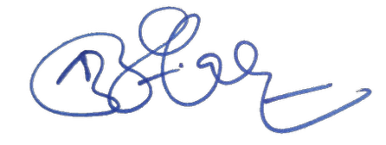

____________________
Collector
GST and BITS Project

