Explanatory Clarification of Digital Health Platform (DHP) System Development for Bhutanese Vendor
The tasks for Bhutanese Vendor engaged in the DHP System Development is primarily guided by Figure 1: Bhutanese Vendor Task (RFP) that sets the overarching scope distribution for Bhutanese Vendor. In addition, Bhutanese vendors are encouraged to craft their proposals while considering the specific details outlined in Figure 2: Requirements Definition. These detailed requirements provide a crucial blueprint for the vendors, ensuring that their proposals align closely with the specific features, functions, and technical elements of the project.
Importantly, when it comes to the distribution of roles and responsibilities among these vendors and especially tasks for Bhutanese Vendor, it is Figure 1 Bhutanese Vendor Task (RFP) that takes precedence. It specifies the tasks and assignments for each vendor, effectively shaping the collaboration and contributions of each participant throughout the system development process.
Figure 1: Bhutanese Vendor Task (RFP)
(Please refer to RFP file: Figure in Section 6. Terms of Reference (TOR) page 28 )
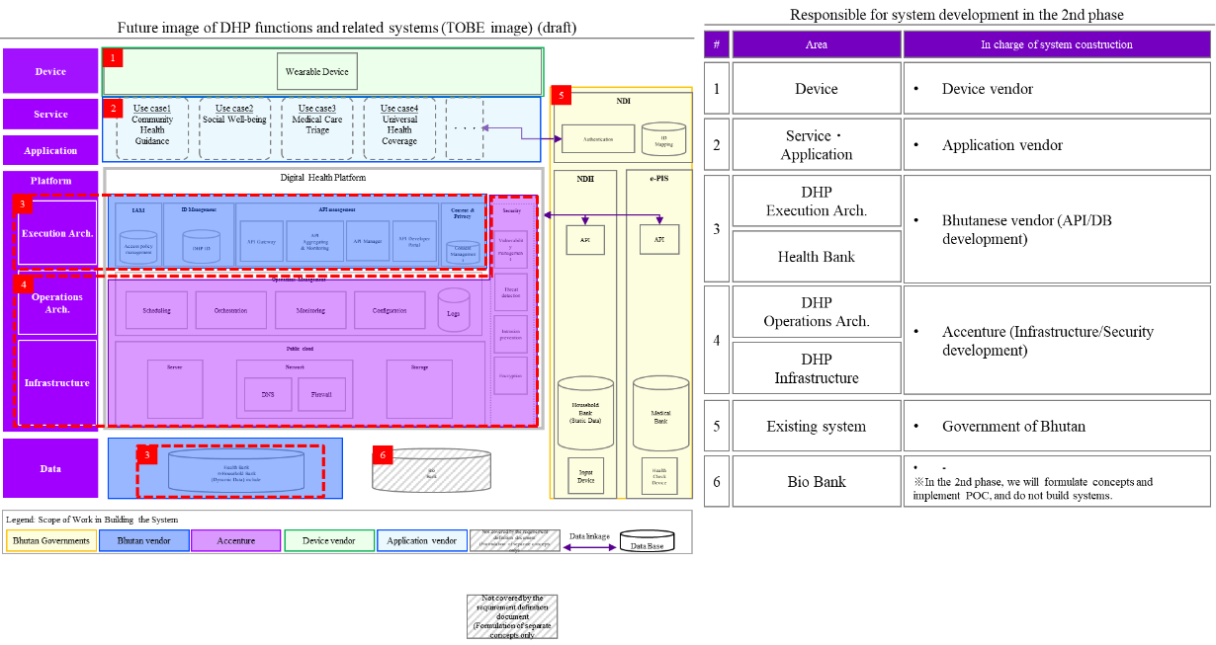
Figure 2: Requirements Definition
(Please refer to “Requirement Definition Document” file :Figure in 1. Introduction Scope of this document page 7 )
